Contents:
- Required tools for install
- Default CAN keyboard settings
- About CAN speed and ECUMaster Light Client download location for programming keyboard
- Wiring and mounting - Mating connector part number – Wire colors
- Using the ECUMaster Light Client to program CAN speed and CANopen node ID
- Adding and configuring CAN keyboard in PMU Client
- Verify CAN button output and activating PMU Power Outputs with CAN button States
- Required tools for install:
- Open barrel crimpers – DTT-16-01 professional crimpers are used in-house. Alternatively, IWISS model IWS-1424A parallel crimpers will require practice for quality crimps, but are an affordable solution.
- Wire Strippers
- 120 Ohm resistor (if required- see “CAN Terminating resistor note”)
- Default CAN Keyboard settings:
- CAN Speed/Bitrate: 500 kbps (125k, 250k, 500k, 1Mbps programmable with ECUMaster Light Client and USB to CAN module)
- CANopen Node ID: 15 (programmable with ECUMaster Light Client if (2) keyboards are required for PMU)
- About CAN speed and ECUMaster Light Client download location for programming keyboard:
A CAN bus channel will stop functioning correctly if the keyboard is connected to a CAN bus that is not set to the default 500 kbps. See section 5 for information on reprogramming CAN bitrate speed.
ECUMaster Light Client can be downloaded from: https://www.ecumaster.com/download/
  - Note for ECUMaster ADU, PMU:
CAN 1 is 1 Mbps which cannot be changed. The CAN Keyboard must be reprogrammed to 1 Mbps BEFORE connecting to CAN 1. CAN 1 will not function if the keyboard speed is not reprogrammed to 1 Mbps and Client software communication will fail while trying to connect to the ADU or PMU for programming.
CAN 2 can be set to 500 kbps in the ADU or PMU Client to match the default CAN Keyboard speed.
  - ECUMaster EMU Black has only one CAN channel. The CAN speed setting in the EMU CAN parameters must be set to match the CAN speed programmed into keyboard. Enable the built-in CAN Terminating resistor in the EMU Black Client.
Note: The CAN Keyboard is not intended to be used with the ECUMaster EMU Classic.
- Wiring and mounting:
The mating connector type is Amphenol AT06-4S.
  - Terminal Number- CAN Keyboard Color- Function
Terminal #1 - (Blue) - CAN L
Terminal #2 - (White) - CAN H
Terminal #3 - (Black) - Ground
Terminal #4 - (Red) - Power (12-24V)
  - CAN terminating resistor tech note:
A CAN network normally requires a total of (2) 120 Ohm terminating resistors to be installed on a CAN bus network to function. The ADU, PMU, and EMU all have built in 120 Ohm resistors that can be enabled.
(1) 120 Ohm terminating resistor must be physically bridged from CAN H to CAN L if a CAN keyboard is connecting to only one controller device with a built-in resistor feature, (example: CAN Keyboard connected to ECUMaster EMU Black only).
A resistor does not need to be installed if a CAN Keyboard is connecting to and CAN bus network that is connected to (2) controller devices, (example: CAN Keyboard connected to a CAN network between PMU and EMU Black).
Verify the “120 Ohm Terminator” is enabled in the EMU Black, PMU, or ADU. (See the EMU, PMU, or ADU documentation or software for enabling the built-in CAN terminating resistor.
  - Crimping and assembling the AT06-4S mating connector with CAN terminating resistor:
The mating terminals should be crimped using an open barrel crimp tool. We use the 18 AWG to 20 AWG DTT-16-01 professional crimp tool, though other open barrel crimp tools can be used.
The 120 Ohm resistor leg can be inserted with the wire when crimping the CAN H and CAN L terminal. (See photo below). Tip: Twist the leg of the resistor around the copper conductor before crimping to keep resistor leg in place while crimping.
    - Trim harness wires to equal length, strip wire insulation 1/8”, then crimp terminals onto wires.
    - To prevent shorting, cut 5/32” diameter heat shrink only long enough to cover each CAN wire and resistor leg (not covering terminal), slide heat shrink down over CAN terminals until heat shrink stops at resistor, and use heat gun to shrink tubing.
    - Verify the terminal lock is removed from the AT06-4S mating connector then insert each harness wire into the correct terminal location verifying each terminal is fully inserted into the connector and terminals lock into place. The terminal numbers are located on the back of the AT06-4S connector.
Terminal #1 - CAN L
Terminal #2 - CAN H
Terminal #3 - Ground
Terminal #4 - Power (12-24V)
    - Lightly tug each wire to verify they are securely locked in place, verify connector seal is in place, then insert the terminal lock into connector until it snaps firmly in place.
Mating connector wiring with installed CAN terminating resistor shown below. push them through the seal AT06-4S mating connector is completed, the keyboard can be attached to CAN 2 bus speed is set at 500 kbps.
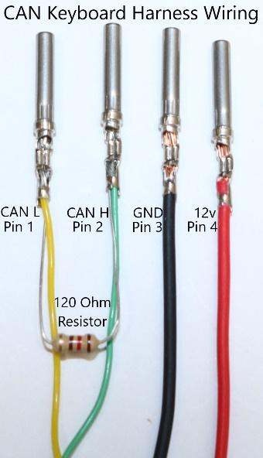 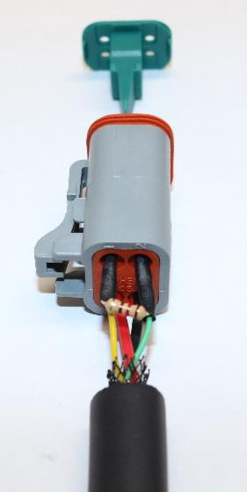 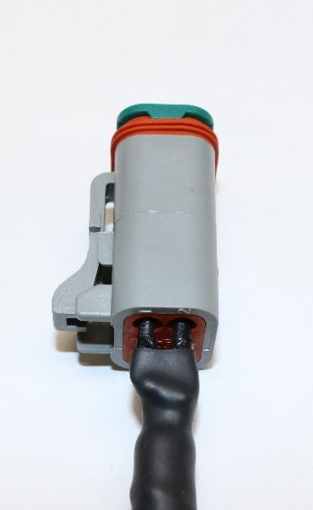
    - Mounting the keyboard:
Button numbers are stamped into the rear of the keypad. Mount keyboard with button #1 in the upper left position.

- Using ECUMaster Light Client to program CAN speed and CAN Open Node ID:
For instructions using the ECUMaster Light Client to program the keyboard, use the link below to view the following Light Client manual chapters:
https://www.ecumaster.com/files/LightClient/LightClientManual_1_0.pdf
  - Setting the keyboard to another CAN speed – see 11.2. Changing CAN bit rate of devices
  - Changing CANopen node ID to use (2) keyboards on PMU – see 11.3. Changing CAN Keyboard CANopen node ID
- Adding and configuring CAN keyboard in PMU Client:
The PMU Client can be downloaded from the following if not already installed: https://www.ecumaster.com/download/
  - Verify the USB to CAN module is connected to the PMU on CAN1 and the USB to CAN terminator switch to the “ON” position.
  - Apply power to the PMU, then open the PMU Client software and verify the green “CONNECTED” status on the lower left of the PMU Client window.
  - Click “Add” in the Project Tree window then select “CANbus Keyboard”.
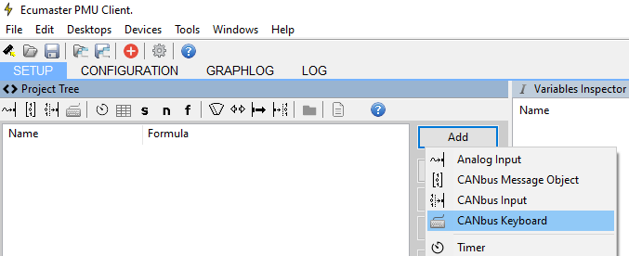
  - The New CANbus Keyboard configuration window will open. In the “Size” field, select which type of CAN keyboard is connected. Example: The 4 button keyboard is 2x2 ECUMaster (7 Color), 6 button is 3x2 ECUMaster (7 Color), etc...
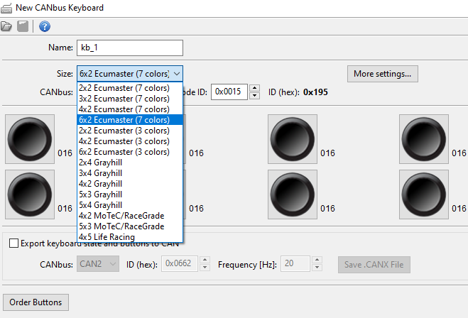
  - In the top “CANbus:” field, select if the keyboard is connected to CAN 1 or CAN 2.
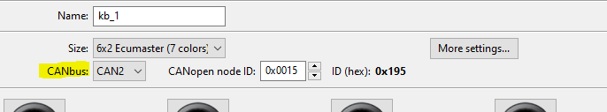
  - Left click each button to name it, choose button type, choose 1 to 3 states in “Last State”, default state, the LED color of each state, and optionally “set Channel” to assign an input channel that can trigger the state of that button.
(If a second PMU or an ADU is installed, skip to Step 6.6. If not, continue Step 6.5)
When all keyboard buttons are configured, click “OK” to complete the CAN keyboard button configuration step, “Make Permanent”, save your changes to the PMU Project file, then skip to Step 6.8.
For specific information on the “Button Type” and other button parameters, click the blue “?” Help Button in the PMU “Edit Keyboard Button” window.
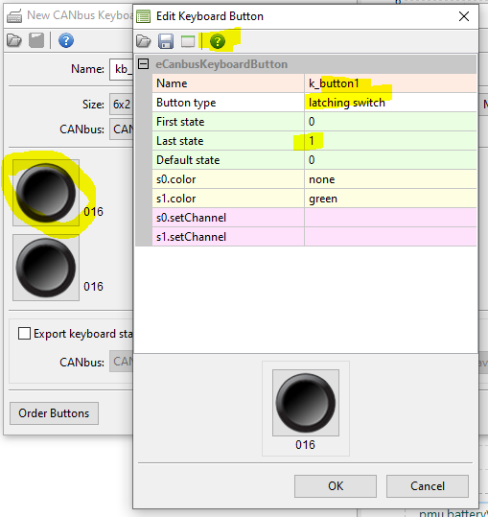
  - Export keyboard state and buttons to CAN:
The CAN keyboard button states and LEDs should be configured and controlled from one PMU device only. When a second PMU or an ADU display is installed, “Export keyboard state and buttons to CAN” can be enabled to broadcast the CAN keyboard button states across the CAN1 or CAN2 channel to another device by importing a specific CANX file into the second PMU or ADU display. This CANX file must be generated by the “Save .CANX File” button.
To create the CANX file:
Select the CAN network the other devices are connected to.
Leave “ID (hex):” or “Frequency [Hz]:” at their default values unless you know those values should change.
Click the “Save .CANX File” button, name the file, then save the CANX file on your laptop drive.
After the .CANX file has been saved and buttons configured, click “OK” to complete the CAN keyboard button configuration step, “Make Permanent”, then save your changes to the PMU Project file.
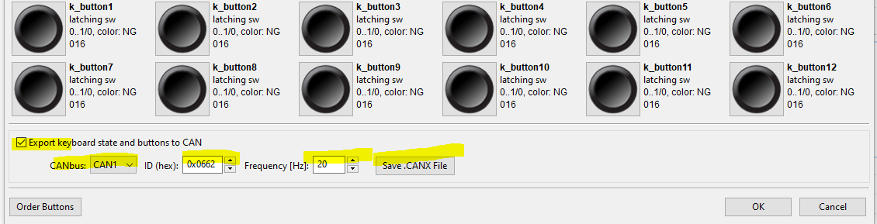
  - Importing a CAN Keyboard CANX file to a second installed PMU or installed ADU:
Connect to or open the Project File of the other PMU or ADU.
Click “Add” in the Project Tree of the other device.
Click “Import .CANX/.DBC File” then select the generated .CANX file. (kb_1.canx is the default name)
Verify “CANbus” channel and “Base ID” are correct (if changed), click “Select all”, then click “OK”.
- Verifying CAN button functionality and activating PMU Power Outputs with CAN button States:
This section will walk through verifying the CAN buttons cycling through their button States and the simplest way to program a PMU power output to watch the “State” of a CAN keyboard button. Programming the Power Outputs in this way will help the user to gain knowledge on how to work with CAN States when creating more complex and simple “Functions” in the future.
If a keyboard button was previously configured as a “Latching Switch” with “Last State” “1”, that button will cycle between States “0” or “1” with each press of the button. If the button was configured as a “Latching Switch” with “Last State” “3”, each press of the button will cycle through button States “0”, “1”, “2”, and “3”.
  - Verify functionality CAN keyboard buttons:
Verify each configured CAN button is functioning and cycling through the button States correctly during each press. Confirm the PMU Client is “CONNECTED” to the PMU and follow the steps below.
    - In the PMU Client, look at the “Graph Log” window to verify it is not paused and is actively logging. When the Graph Log is logging, the time scale at bottom of the Graph Log window will be incrementing time.
    - Under the “SETUP” tab, the “Variables Inspector” window will show all CAN buttons along with the CAN States in the “Value” column. (See screenshot under step 7.2.3)
    - Press each CAN keyboard button to verify the button State changes through all button States.
    - Move on to Section 7.2 correct functionality has been confirmed on all CAN keyboard buttons. If the “Values” in the “Variables Inspector” do not change when a CAN keyboard button is pressed, verify the Graph Log is not paused, click the CAN keyboard in the Project Tree to verify CAN channel is correct, and start back to Section 2 through Section 5 to verify the keyboard settings were correct when adding it to the project.
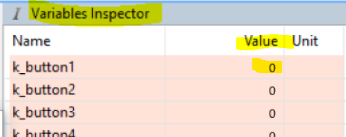
  - Adding a PMU “Power Output” for keyboard:
    - In the PMU Client “Project Tree” window, click “Add” and select “Power Output” to input the following:
- Name: (Name the output)
- Pin: “single” and click the arrow in the field to the right to choose which “Power Output” to activate.
- Max current [A]: (change to higher value if necessary), Leave the rest at their default values.
    - Click the “Formula:” round radio button at the bottom left of the window to enable and open the Formula window.
    - Click the “Add” button to the right of the Formula window to open the “Add operation” window.
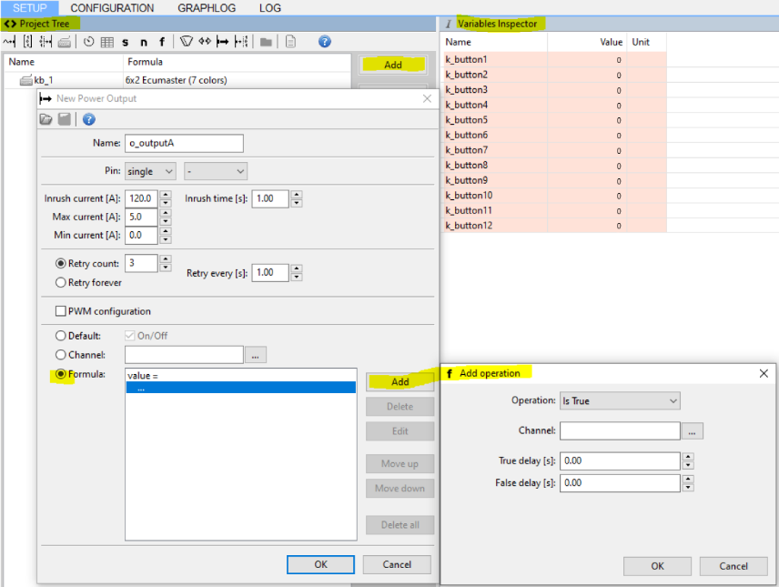
    - In the “Add operation” window, choose the following parameters below:
- Operation: “Equal”
- Channel: “k_button1” (default button name from example)
- (No changes to True or False delay)
    - Click “OK” in the “Add Operation” window after configuring.
    - Click “OK” in the “New Power Output” window, then “Make Permanent” and save project.
    - Press the “k_button1”, or other CAN keyboard button programmed to that output, to verify that the Power Output activates in the “Output Monitor” window by watching for the “Light bulb” indicator or the “Active” Status.
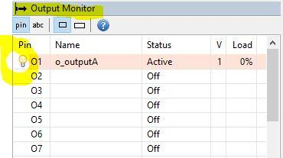
    - When this is configured and functioning correctly, you can continue setting the PMU Power Outputs for the other CAN keyboard buttons. Always remember to “Make Permanent”.
    - Save the PMU project when all buttons are setup, then experiment by re-opening the keyboard file under the Project Tree, selecting any button to open the “Edit Keyboard Button” window, and change the “Button type” to Radiobutton, Indicator, etc.. and clicking “OK” in the “Edit Keyboard Button” window, then click “OK” in the “Edit CAN Keyboard” window to apply the changes for testing.
The “?” Help button in the “Edit Keyboard Button” window will open the help manual page to the “Button type” descriptions and contains other example links about the Radiobutton and Indicator selections.
